**Explain the difference between scaling out and scaling up as two alternative solutions to increased request load within an application**

* Scaling out is adding more equivalently functional components in parallel to spread out a load. This would be going from two load-balanced web server instances to three instances.
* Scaling up, in contrast, is making a component larger or faster to handle a greater load.

**What is different between SOAP and RESTFUL?**

* SOAP only works with XML formats whereas REST work with plain text, XML, HTML and JSON.

**Or**

* The SOAP protocol specifies the rules for using XML to package messages.
* REST is an approach with a very constrained style of operation, in which clients use URLs and the HTTP operations GET, PUT, DELETE and POST to manipulate resources that are represented in XML.

**What is different between Web Server and Web Service?**

* **Web server** provides basic HTTP services, where as web services provide services based on the operations defined in their interface.
* **Web services** can be provided by web servers therefore they are an extension of the Web.
* Web services servers **need not** be web servers.

**What is Different between Application servers and web servers?**

**Web Server**

* is a service that handles specifically requests in the HTTP protocol format.
* is a computer program that accepts the request for data and sends the specified documents.

**Application Servers:**

* An application server is a service that handles specifically requests for business operations and performs business logic.

**Consider the following figure that explains the web service infrastructure and components. Explain what is meant by directory service, and Service descriptions.**

* service description includes an interface definition and other information.
* Directory service: naming or directory service allow clients to find out about services

**Explain the Web services Infrastructure and Components (Very Important)!**

* in XML. SOAP is used to encapsulate these messages and transmit them over HTTP or another protocol
* Web services and applications may be built on top of other web services
* Some particular web services provide general functionality required for the operation of a large number of other web services. They include directory services, security and choreography,
* naming or directory service allow clients to find out about services

**What is difference between Microservices and monolithic style?**

* **The monolithic architecture** is built as a single and indivisible unit. [traditional way]
* **a microservices architecture** breaks it down into a collection of smaller independent units. These units carry out every application process as a separate service.

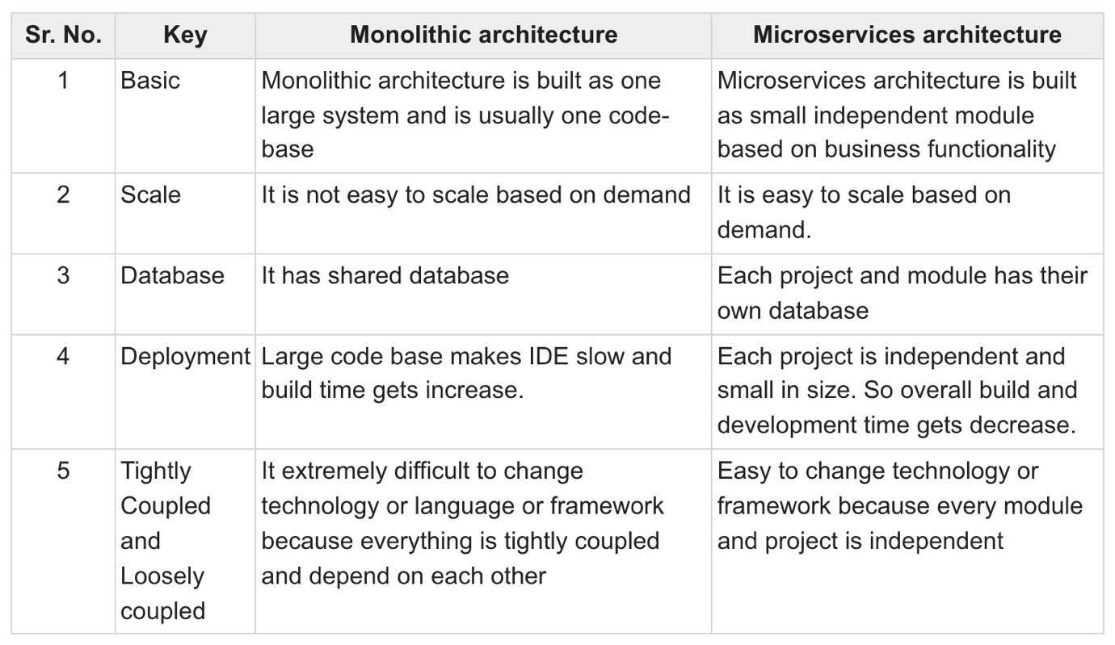

**Prescriptive vs. Descriptive**

* prescriptive: captures the design decisions made prior to the system’s construction. { as-conceived }
* descriptive architecture describes how the system has been built {.as-impalement }

**Architectural drift vs Architectural erosion**

* drift is principal design decisions into a system’s descriptive architecture that not included in prescriptive and not violate any of the prescriptive architectural
* erosion is design decisions into a system’s descriptive architecture that violate its prescriptive architecture

**Architectural recovery**

is the process of determining a software system’s architecture from its implementation- level artifacts

**Structures vs. Views?**

* A structure is the set of elements itself.
* A view is a representation of a structure(s)